**Training Documents**

**Azure**

**IBMi Board Information**

**Azure Board Column Descriptions and How they are Used**

**Examples of Good Test Plans in Azure**

**QA Process Most Frequently Asked Questions**

**Business Process Most Frequently Asked Questions**

**QA Process for systems other than Titan (PMS)**

**Progressing through all the TITAN Statuses**

**Query to Find Your Items in Azure**

**AZURE Testing BLIs and Creating Bugs**

**How to Add/Create New BLIs**

**Azure**

Azure is where the Quality Assurance Analysts and Business Analysts keep track of Titan items. There are columns/lanes for each state that the item is in, described in the section below. Also, there are different boards for each type of item. For example, there is a documents board for any new documents that are added or for any changes made to documents. The URL below will bring you to the Titan Maintenance Board.

[https://ms21stmortgage.visualstudio.com/TITAN/_boards/board/t/Maintenance/Backlog%20items?parameters=Backlog%20items](https://ms21stmortgage.visualstudio.com/TITAN/_boards/board/t/Maintenance/Backlog items?parameters=Backlog items)

**Overview of Lane Descriptions/How they are used**



*DEP-* (Dependent) Used by Dev and SQA when unsure of specs or BLI/Bug is not ready to be programmed

*Ready for Development-* Used when the SQA is adding new backlog items or CRs. Developers will look at this column when looking for their next work item to program.

*BLIs with Findings-* Place an item in this lane when creating a bug for an item that you are testing.

*In Development*- Used by the developer when they are actively programing BLI’s, CRs, or Bugs

*Ready for Publish-* Used by the developer when they are done programing and the item is ready to be published to the testing environment.

*Published to QA*- Used by the developer when an item has been published to testing environment.

*QA Testing*- Used when the SQA is completing testing

*Retest pending-* Used when the SQA has completed the first round of testing for the main BLI, but there are outstanding bugs that need to be addressed by developer.

*Ready to publish with Dependencies-* Used by SQA when there are multiple bugs. If the first bug is fixed but there are still outstanding bugs, then you would move the first bug to ready to publish with dependencies while you wait for the remaining bugs to be fixed by the developer.

*Ready for BAT*- Used by SQA when testing of a BLI, CR, or bugs are completed. Move all items to this column when testing is complete. (BLIs and related Bugs)

*BA Testing-* Used by business analysts when they are completing business acceptance testing on an item.

*Ready to Publish to Production*- Used by business analysts when they have completed BAT (business acceptance testing)

*Done-* Used after an item has been published to production

**Examples of BLIs with Good Test Plans**

**\*See “Acceptance Criteria” section for test plan examples in the following BLIs:**

[Product Backlog Item 40015](https://ms21stmortgage.visualstudio.com/TITAN/_workitems/edit/40015): Create new Condition #415

[Product Backlog Item 41714](https://ms21stmortgage.visualstudio.com/TITAN/_workitems/edit/41714): CR: Add new Approval Conditions 428 and 429

[Product Backlog Item 31052](https://ms21stmortgage.visualstudio.com/TITAN/_workitems/edit/31052): New Doc - NC Conditions Letter

**IBMi Board:**

1. PR (project) is assigned to SQA Analyst, and QA Receives an email notifying them that they have been assigned the PR. Assigned- QA creates a back log item in TFS using the link below

* [https://ms21stmortgage.visualstudio.com/TITAN/_boards/board/t/IBMi%20Projects%20(QA%20tracking)/Backlog%20items/?parameters=Backlog%20items](https://ms21stmortgage.visualstudio.com/TITAN/_boards/board/t/IBMi Projects (QA tracking)/Backlog items/?parameters=Backlog items)

1. Details to add to BLI on IBMi Board:
   1. Add the PMS Project # and Title as the BLI Title
   2. Copy/past Project Details into the BLI
   3. Move to appropriate lane based on the project’s category
   4. Set yourself as the QA Assigned
   5. Assign the BLI to the I Developer
   6. Set the Project Leader Field to the Project Manager
   7. Add the target date in the QA Target Date Field
   8. Add Stakeholder as a tag on the BLI: “Stakeholder <insert Stakeholder name>”
2. Write test plan and upload to BLI
3. Log the Total Time that you spend on the item in the Effort field
4. Log any findings in the QA Findings Count field
5. Log any change requests in the QA Change Request Count field
6. Update QA Target Date to match the target Date on the PMS if target date changes
7. The QA Started Date and QA Completed Date should automatically populate, but double check the item to insure that these fields populate correctly. QA Started Date should populate when the item moved to the QA Testing Column. QA Completed Date should populate when the item moved to the Ready for BAT Column.

*Note:* If you are doing specs for a project, please add a BLI for that and include the project leader tag and a tag that says “SPECS” so that you can still track your time and we can report how much time we spend helping with specs.

Examples:

Most Frequently Asked QA Process Questions

1. Do I need to create additional bugs for the same issue?

* If you have a bug that the devs work on and it gets published to QA, but that bug is not fixed, you do not need to create a new bug. You should move the existing bug back to BLIs with Findings, email the developer to let them know that it was not fixed, and add a ‘1’ tag to the item to denote that you have had to send that item back one time. (If you send it back again, you can remove the ‘1’ tag and add a ‘2’ tag to denote that it has gone back to the dev twice.

1. What do I put in the acceptance criteria when testing a bug?

* When you re-test a bug, you just need to put your testing steps confirming that the bug is fixed. If there isn’t a main BLI, then you can definitely put additional testing steps in the bug as a form of regression testing to confirm existing behavior is still working as expected.

1. If a BLI or CR does not specifically state that it is only for new CF, should I test them on both new and legacy files?

* Yes, you always want to check legacy files

1. How to print documents without the documents actually printing?

* Set Default Printer to Microsoft Print to PDF
* Open your File Explorer
* Then go to Documents
* Then select the Titan Printed Documents Folder to find the printed docs

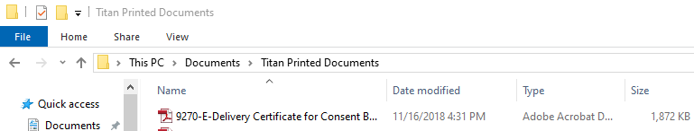

1. What is the difference between warnings and errors on fields within TITAN?

* Warnings are just indicators of something unusual. You can save the customer file when there are warnings visible.
* Errors are hard blocks, you need to fix the ‘error’ in order to save

1. How to book a loan in QA or UAT?

* You have to use TITAN (32-bit) option from the intranet. Once you click the ‘Start Booking’ button from the Ready to Book Queue in TITAN32, you will be taken to the booking system in Lotus Notes to complete the booking process.

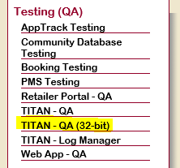

1. How do I get to a command line in iMenu?

* There is a menu option= Command Line

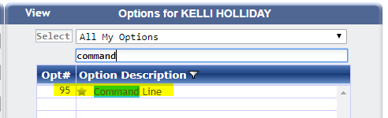

Most Frequently Asked Business Process Questions

1. Do sub pending list items appear on the actual Pending List Document?

* Only main items appear on the Pending List document that is sent out because the sub items are an internal checklist to confirm that we have everything that we need in order to sign off on the main pending list item.

1. When an approval condition is “Required Before Funding” when will it display on the Retailer Portal?

* We display “Required Before Funding” conditions on the retailer portal only when CF Status is Ready for Docs or Further

1. When will the Disbursement Worksheet be displayed in the Retailer Portal?

* You have to get the CF to Booked status and then select the link Disbursement Worksheet

1. Can you add a Co-Signer borrower on Web Apps?

* No, you can only add Co-Applicants

1. What SOJ is included in TitleCompanyStatesEnum?

* New Hampshire

1. What is the iMenu option to change accounts to BK I/O and other BK Statuses?

* Bankruptcy/Legal Entry/Maint

**QA Process for systems other than Titan**

**PRs where QA is handling Specs**

1. Project Leader communicates to SQA manager that SQA team member is needed for specs development
2. SQA Manager assigns SQA team member to project
3. Meetings and requirement gathering take place
4. SQA creates specs based on requirements (works with Project Leader and Project Sponsor)
5. SQA sends/presents final specs to all parties involved
6. Project Sponsor approves project
7. Development takes place
8. Developer conducts unit testing and documents as they are required by their PL
9. Developer sets project to In Testing by adding date to Ready for SQA field
10. SQA conducts testing
11. Follow Development/QA process

**Development/QA Process**

1. Developer completes programming requests based on project specifications
2. Developer completes unit testing and documents testing as required by their PL

*\*Note to developer: please make sure your objects are in QUA at this point*

1. Developer enters current date in ‘Ready for SQA Test/Retest Date’ field (under Assignment tab)

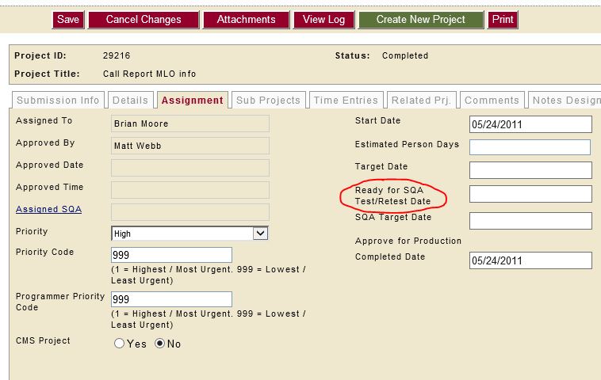

1. PR is then automatically set to ‘In Testing’ and routed to SQA Manager who will assign an SQA TM as well as a SQA target date
2. SQA reviews specs and writes test plan
3. SQA emails test plan to all parties involved and asks for feedback and gives everyone an opportunity to contribute- i. Make sure in the Subject Line to include the title of the project along with the PR # ii. Make sure to include the Project Leader/Manager, Assigned Developer, Kelli/Danielle, and Project Stakeholders iii. You can say something like this when emailing everyone the test plan: Attached is the test plan for this PR. If anyone has any questions or thinks of something that needs to be added please let me know. I will also attach this to the PR.
4. Assigned SQA will conduct full testing. He/she will communicate with developer/Project leader/Project Sponsor if there are any questions/clarification needed during the process. *\*Note: Always include Carolina on ALL communication*
5. Assigned SQA documents test cases and findings (if any) in detail. Documentation is attached to PR and placed in the Project Folder
6. If there are findings, QA will set PR back to ‘In-Development’ by removing the ‘Ready for SQA Test/Retest Date’ and saving the PR. SQA will communicate issues to developer through PMS (developer will get email through PMS advising of such)- *\*Note: Always include PL and SQA Mgr on your dev-QA findings communication*
   1. Developer addresses findings and sends it back to SQA for re-test by entering a Date on Ready for SQA Test/Retest
   2. Go to step 7
7. If there are no findings, go to next step (step 9)

1. QA will make a note in the PR specifying that testing is complete and PR is ready for Business Acceptance Testing
2. QA will coordinate Business Acceptance Testing with the appropriate person(s), typically the stakeholder(s) listed on the project (include developer/PL in case they want to attend)
3. If there are any findings, QA will document these (categorize as BAT findings) and communicate with developer through PMS. Go to Step 8a
4. If there are no findings, go to step 11
5. If there are any changes, QA will document these (categorize as BAT Change Request) and communicate with PL to determine if another project is needed or if it can be addressed in the same project
6. If another project is needed, the Stakeholder will write specs and enter PR
7. If change can be addressed within the current project, SQA will document and communicate with developer through PMS
8. If no changes requested, go to step 11
9. Ask business stakeholder to approve the project by clicking the ‘Approve for Production’ link within the PR.
10. SQA manager ‘Requests for Promotion’

**Progressing through all of the Statuses**

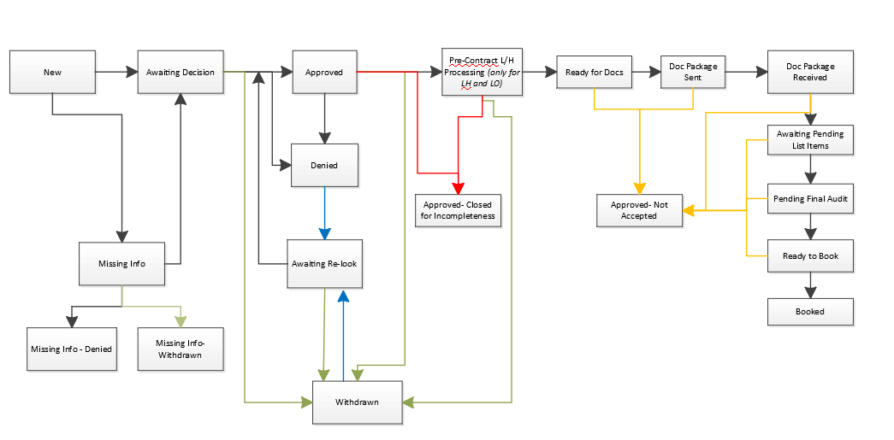

New Can Go To:

Awaiting Decision

Missing Info

Missing Info Can Go To:

Missing Info-Denied - End

Missing Info-Withdrawn - End

Withdrawn Can Go To:

Awaiting Decision

Awaiting Decision Can Go To:

Withdrawn

Approved

Denied

Denied Can Go To:

Awaiting Re-look

Awaiting Decision

Awaiting Re-look Can Go To:

Withdrawn

Approved

Denied

**Final Statuses** = Missing Info-Denied, Missing Info- Withdrawn, Denied, Withdrawn, Approved- Closed for Incompleteness, Approved- Not Accepted, Booked.

**Status Triggers**

Deny: *Button.* *Located on Denial Info Screen.* Button will be enabled if:

* User has the Associate Credit Manager, Credit Manager, Sr. Credit Manager, Floor Supervisor, or Company Officer role selected on TM Profile
* The user is listed as the Assigned Credit Manager on the Assigned Team Member Screen
* CF Department = Retail or Homes for Sale AND user is Licensed in the CF POS State
* User is Authorized in CF POS State
* Supervisor Review Stamp field is NOT visible
* CF Status does NOT = Missing Info-Denied, Missing Info-Withdrawn, Denied, Withdrawn, Approved-Closed for Incompleteness, Approved-Not Accepted, or Booked
* Original CF Status does NOT = Awaiting Decision or Awaiting Re-look AND Current CF Status does NOT = Approved or further

Approve: *Button. Located on Approval Info Screen.* Button will be enabled if all of the following are true:

* System accesses Customer File AND ‘21st AUW Eligible Flag’ = Yes ***OR***
* User accesses Customer File AND:
* User is listed as the Assigned Credit Manager on the Assigned TM Screen **OR** [User is not listed as the Assigned Credit Manager AND CF Status does NOT = Awaiting Decision or Awaiting Re-look]
* User has the Associate Credit Manager, Credit Manager, Sr. Credit Manager, Floor Supervisor, or Company Officer role selected on TMM
* User is Authorized in the CF SOJ (see TMM for more details)
* The value in the ‘Approval Counter’ is less than 5
* CF Status=Awaiting Decision, Awaiting Re-look, Approved, Pre-Contract L/H Processing, Ready for Docs, Doc Package Sent, Doc Package Received, or Awaiting Pending List Items

**Note: After Approve button is selected for the first time (Approval Counter = 0), button will be disabled until the Customer Approval Package is printed. Once the CAP is printed, button will become enabled again.

Withdraw: *Button.* Button will be located on the Title Bar of the Customer File. Selecting button will launch the Withdraw Wizard in a modal window (see below for details). Button will be visible and enabled when:

* CF Status = Approved AND user has at least one of the following roles selected on TM Profile: Associate CM, CM, Sr. CM, Broker Rep, Loan Originator, Broker Dept Manager, Direct Dept Manager, Floor Supervisor, or Company Officer ***OR***
* CF Status = Missing Info, Awaiting Decision or Awaiting Re-look AND user has at least one of the following roles selected on TM Profile: Floor Supervisor or Company Officer

Ready for Land/Home: *Button. Located on Approval Info Screen. Button will only be visible if [Collateral Type = Land/Home or Land Only OR SOJ is included in the TitleCompanyStatesEnum] AND CF Status=Approved.* Button will be enabled if all of the following are true:

* User has the Assistant LH Coordinator, LH Coordinator, LH Manager, Broker Rep, Loan Originator, Associate Credit Manager, Credit Manager, Sr. Credit Manager, Broker Dept Manager, Direct Dept Manager, Floor Supervisor, or Company Officer role selected on TM Profile

Ready for Docs: *Button.* *Located on Approval Info Screen.* Button will only be visible when Collateral Type=Chattel AND SOJ is NOT included in the TitleCompanyStatesEnum AND CF Status=Approved.

Button will be enabled if all of the following are true:

* User has the Tax Rep, Chattel Processor, Assumption Processor, Broker Rep, Loan Originator, Associate Credit Manager, Credit Manager, Sr. Credit Manager, Broker Dept Manager, Direct Dept Manager, Floor Supervisor, or Company Officer role selected on TM Profile

Ready for Docs: *Button. Located on Pre-Closing Screen.* Will be visible on Pre-Closing Screen when Collateral Type = Land/Home or Land Only ***OR*** Subject Property State is included in TitleCompanyStatesEnum. Button will be enabled when all of the following are true:

* CF Status = Pre-Contract L/H Processing
* ‘Pre-Closing Checklist Complete’ checkbox = Selected
* User has at least one of the following roles selected on TM Profile: L/H Coordinator, L/H Manager, Floor Supervisor, or Company Officer

Send Doc Package: *Button. Located on Doc Selection Screen. Enabled only if Status= Ready for Docs or further AND an include checkbox selection is made (if checkbox is visible).*

Check-In: *Button. Located on Customer File Search in Search Results section.* Button will be enabled if:

* At least one Customer File checkbox in the Search Results = Selected

When user selects Check-In button the system will determine if the selected CF(s) need to go through the Blocked or Unblocked path:

CF will go Unblocked Path if:

* Customer File is not locked by another user
* CF Status = Doc Package Sent

CF will go Blocked Path if:

* Customer File is locked by another user
* CF Status does NOT = Doc Package Sent

Send Pending List: *Button.* *Located on Pending List Screen.* Button will be disabled if either of the following are true:

* CF Status < Doc Package Received
* User has the Inquiry Only role selected on TM Profile

Ready for Final Audit: *Button.* *Located on Pending List Screen*. Button will be enabled when:

* All Approval Conditions = Accepted or Waived
* All Pending Listing Items = Accepted or Waived
* User has one or more of the following roles: Chattel Processor, Direct Dept Manager, Assistant LH Coordinator, LH Coordinator, LH Manager, Funding Auditor, Floor Supervisor, or Company Officer role selected on TM Profile

Ready to Book: *Button. Located on Pending List Screen. Button will only be available/visible when CF Status=Pending Final Audit.* Button will be enabled when:

* All Approval Conditions = Accepted or Waived
* All Pending Listing Items = Accepted or Waived
* All Final Audit Items = Accepted or Waived
* User has one or more of the following roles: Funding Auditor, Funding Manager, LH Coordinator, LH Auditor, LH Manager, Floor Supervisor, or Company Officer role selected on TM Profile

Start Booking: *Button. Located on the Ready to Book Queue within Titan. Button will only be available/visible when CF Status=Ready to Book.*

* To access the Ready to Book Queue user has one or more of the following roles: Funding Auditor, Funding Manager, Floor Supervisor, or Company Officer role selected on TM Profile

**Query to find your items in Azure:**

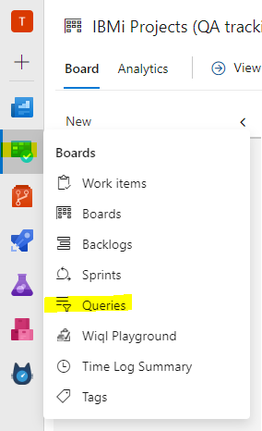

1. Click ‘Queries’
2. Click ‘New Query’
3. Click ‘Add new clause;
4. Select the Field ‘QA Assigned’
5. In the Value field Search for your name
6. Select Run Query

Example:

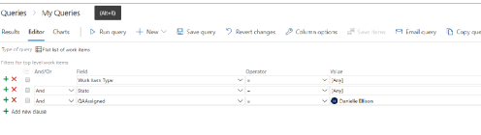

Azure Training

**When testing an item make sure to complete the QA Fields**

1. Set yourself as the QA Assigned
2. Log the Total Time that you spend on the item in the Effort field
3. Log any findings in the QA Findings Count field
4. Log any change requests in the QA Change Request Count field
5. The QA Started Date and QA Completed Date should automatically populate, but double check the item to insure that these fields populate correctly. QA Started Date should populate when the item moved to the QA Testing Column. QA Completed Date should populate when the item moved to the Ready for BAT Column.

**When creating bugs, please make sure that**

* You are linking them to the related BLI
* You are naming it as ‘Finding for <insert BLI number>’ :Give a brief description of what the bug is about
* You are tagging with the appropriate piece and priority
* Always use pictures/illustrate, be thorough in the ‘Repro Steps’ box.
  + State the Current Behavior
  + State the Desired Behavior *use the word ***should*** so it’s super clear
  + List the steps to reproduce the bug
  + On the illustration, show what it’s doing, but most importantly, if you can, show what it should do. Don’t be afraid to explain the illustration (ie: illustration of current behavior vs desired behavior)
* Make sure you reference the CFs you used within your items and what you tested- use Acceptance Criteria section.
* Once the bug is created, then it should go into the BLIs with findings lane.
* Make sure to comment in the finding a brief description of what the finding was and tag the Developer, SQA Manager, and Project Leader into the discussion section

**Tagging BLIs/Bugs:**

1. Tag with Priority

* Low
* Average
* Important
* Urgent
* Critical

To Determine Priority, you can check the feature on the Boot Camp Board, or if you are creating a bug you can check the main BLI, and make sure that it is the same.

1. Tag with Location where the changes will be made (i.e. App Entry)
2. Tag with the type of error on any Bug:
   1. Development Error
   2. Pre-Existing Bug
   3. Development doesn’t meet specs
   4. Error or omissions in specs
   5. Development doesn’t meet specs due to disagreement/technical issue
   6. Spelling/Grammar
   7. Visual Consistency

* If you have a bug that the devs work on and it gets published to QA, but that bug is not fixed, you do not need to create a new bug. You should move the existing bug back to BLIs with Findings, email the developer to let them know that it was not fixed, and add a ‘1’ tag to the item to denote that you have had to send that item back one time. (If you send it back again, you can removed the ‘1’ tag and add a ‘2’ tag to denote that it has gone back to the dev twice. Also, make sure to increase the findings count on the bug and main BLI.

Make sure you are not adding the tags below to your items. These tags are automatically added after a commit is published and are used by Jessica for tracking items.

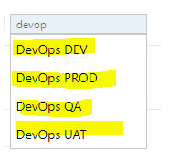

Also, avoid tags that look like this as they are also automatically added to the items and needed for tracking:

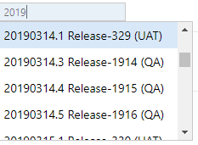

*Example:*

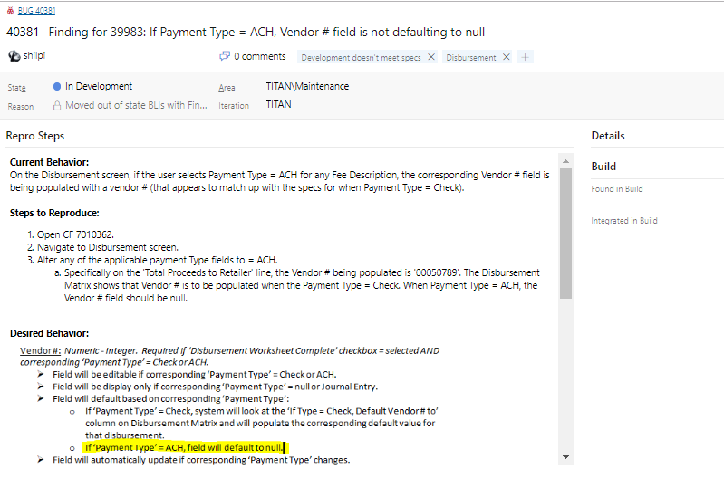

Azure Training

**When you are adding new backlog items and CRs, please make sure that:**

* Go to the Boot Camp Board
* Make sure your view is set to “Features” and you should be able to see the items
* Go to the Ready for Work Items Column
* On the Boot Camp Board there are Swim Lanes for Maintenance and New Features, if an item is in the Maintenance Swim Lane then it should be added to the Maintenance board, if an item is in the New Features Swim Lane, then it should be added to the New Features board.
* If the BLI is not critical or urgent then it should go to the other Change Requests on the Maintenance Board AND if it’s a big item it’s normally a new feature
* You are tagging with the appropriate piece and priority
* If you are adding the BLIs to the New Features board, make sure you are linking it to a Feature- if there’s no feature for that particular item, let the SQA Manager know.
* Always use pictures/illustrate be thorough
* Make sure to document that you added the BLI in the feature on Boot Camp board, make sure to copy and paste the BLI info into the Discussion.
* Once the BLI is created move the item on the Boot Camp board to the Done Column.

**In addition when you are adding BLI’s/CRs items, please make sure that:**

1. Always review the CR and ask questions if something doesn't make sense or you think we're missing something.
2. Copy and paste the text of the "Business Purpose" into the BLI.
   * If you are adding several new items that are part of a Parent feature, you can paste this into the main feature item associated with that Parent feature. You do not need to paste the business purpose into each individual item.
   * If it is a single item, then paste the business purpose text into the BLI.
3. Screen shot the CR and paste the screen shot into the BLI.
4. If you are adding all items pertaining to a CR to their own swimlane (not a generic swimlane on Maintenance or Documents boards), then they do not need to be linked to each other as related, they just need to be linked to a Parent Feature item.
   1. Do not link to the feature item on boot camp board.
   2. Parent Features are usually on the New Features Board
   3. If you are adding items for a CR and you are thinking it needs to be broken down into more than 3 items, review with Kelli and we will determine if it needs to be added as a swimlane on the New Features board.
5. If you are adding items to the maintenance or documents boards and you are breaking a CR down into more than 1 item and those items all need to be published to production at the same time, they must be linked to each other.
   1. If there are 4 BLIs then they should have 3 related links